Project Design Phase
Solution Architecture

Date | 25 September 2026
Team ID | SWTID-2026-9989
Project Name | Script-Controlled ACL – Restrict Record Access Based on Field Value
Maximum Marks | 4 Marks

Solution Architecture:
Solution architecture is a complex process – with many sub-processes – that bridges the gap between business problems and technology solutions. Its goals are to:
- Find the best tech solution to solve existing business problems.
- Describe the structure, characteristics, behavior, and other aspects of the software to project stakeholders.
- Define features, development phases, and solution requirements.
- Provide specifications according to which the solution is defined, managed, and delivered.

Solution Architecture Diagram:

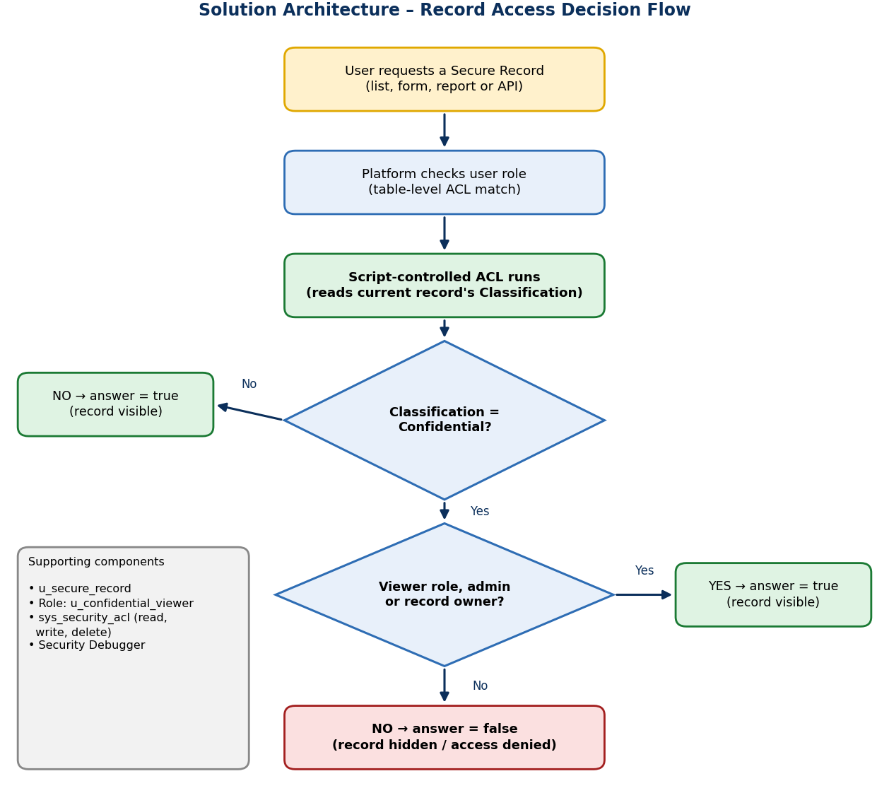
Figure 1: Record-access decision flow of the Script-Controlled ACL
How it works: every request to a Secure Record passes the role check and then the ACL script. If Classification is not Confidential the record is allowed; if it is Confidential the record is allowed only for the u_confidential_viewer role, admin or the record owner; otherwise the answer is false and the record is hidden or access is denied.

